Subject Area OMAS API proposal

Table of Contents

History 1

Requirement 1

Use cases 1

Glossary Use cases 2

Ontology creation use case 3

Classification use cases 3

Reference data use case 4

Tasks 4

Story board UI proposal 4

UI considerations 13

Models 13

Glossary Models 13

Subject Area OMAS API 13

Names and identity 14

Appendix 15

Exposing Terms with different amounts of information 15

UI Visualization styles 16

1) Tree 16

2) Graph 17

3) Grid 18

4) Alphabetised 18

How a User Interface using the Subject Area OMAS might be organised 18

Swagger 18

Mapping from Subject Area OMAS Glossary types to Atlas types 21

Discussion points 22

## History

03/07/2017 Version 1.0 David Radley – Initial draft

06/07/2017 Version 1.1 David Radley – added an early version of a Rest API.

19/07/2017 Version 1.2 David Radley – updated to add more detail and after review comments

29/09/2017 Version 1.3 David Radley – updated to change name to subject matter experts and make more consistent with other OMASes

01/11/2017 Version 1.5 David Radley – Add story boards for glossary

06/11/2017 Version 1.6 David Radley – Add IGC / Atlas considerations

## Requirement

Consumer specific OMAS API for subject matter experts. Jira for this is ATAS-1698.

## Use cases

The use cases for the subject matter expert all relate to how the subject matter expert can use their domain knowledge to structure information so it naturally fits with the domain. This is enabled by the subject matter expert creating terms, their relationships and categories in a glossary. The subject matter expert is also best place to classify terms appropriately for governance reasons – for example retention periods or personal sensitive information.

In addition to creating and maintaining glossary content, the subject matter expert also can create and maintain reference data (definitive very slowly changing key value pairs – for example standard country codes). This document will not cover this use case in the current version.

The OMAS is called subject area rather than Glossary, so that can include all the activities that the subject matter expert performs, including reference data creation.

## Glossary Use cases

Most of the Subject Area use cases benefit from a collaborative approach. A Glossary Project is used to group associated Subject Area content to be worked on.



Figure 1 taxonomy creation use case

Sketch out the glossary – a simple list of candidate terms with optional descriptions

Define Term – author the term in detail what the term is and get it approved.

Define Taxonomy – set up a hierarchy of categories in the glossary. This can involve mapping categories to categories in external categories.

Categorize terms – link terms to categories. This work might involve searching for and linking terms from other glossaries.

### Ontology creation use case



Figure 2 Ontology use case

Sketch out the glossary – a simple list of candidate terms with optional descriptions

Define Term – author the term in detail what the term is and get it approved.

Define dictionary - basic term classification to show how particular terms are used.

Relate Terms – relate terms together, to naturally express the subject matter expert’s domain knowledge.

Define contexts – work with terms that represent context.

Design spine objects – classify terms to indicate that they play a role as an object, attribute or ObjectIdentifier.

### Classification use cases

#### Classification using area 3 classifications

There are some classifications defined in the Area 3 models – like whether something is a concept or a spine object; these classifications are performed by the subject matter expert.

#### Governance Classifications (like personal sensitive information)

In governance, often the governance leaders set the main top level strategy and policy. The privacy officers know the structures of the classifications and terms, so may classify terms. The subject matter expert has the most knowledge about the domain, so can apply their knowledge to make the most appropriate classification decisions.

#### Semantic classification use case

The mapping of glossary terms to assets it not done by the subject matter expert. Instead it is done by the asset owner or curator. There is one OMAS per role – so this use case is not in this OMAS.

### Reference data use case

TODO.

The following seem important but are not currently included in this OMAS:

Import / export

Lineage

## Tasks

We envisage that the subject matter expert will be doing these tasks:

1. CRUD new terms (and Glossary). I want to be able to
   * Create a new word specifying the content
   * Clone a term based on an existing term
2. Link new terms together
3. Categorize terms
4. Classify terms

## Story board UI proposal

There are some architectural decisions we need to make around the UI prior to story boarding it.

1. Do we write the UI assuming that workflow capability exists in the OMRS? Probably need to do this to ensure we can work with IGC.
2. Do we write the UI assuming that versioning exits in the OMRS? How will the OMRS expose this.
3. Do we write the UI to submit a page worth of updates – including a few tree or graph modifications / additions / deletions. Or do we write the UI so every element update results in a Rest call.

The following story boarding assumes that updates for the server will be issued per object.

*An aside:*

*We will need to amend the story board if we want to support bulk commits. If we need to support this we will need an API that many add, delete, update requests could be specified.*

*We will need to amend the story board if the OMAS needs to be workflow aware. We would need an approvers UI as well.*

*We will need to amend the story board if we need to surface versions in a way that the user needs to be aware*

*Undo support will need to surfaced in the UI if that is in scope.*

Figure 3 shows the initial home screen. It might be that we want to introduce the concept of my projects – and show them here. We see 3 main use cases taxonomy and ontology authoring and brainstorming in these cases we are working in a glossary and potentially a project.

* The following screens have text as the labels – I suggest that we find appropriately licensed icons for the buttons – rather than using text.
* Glossaries, Terms and Categories need to have default icons. These can be overridden for particular instances.
* The way in which decorations are done – for example to show classifications, status, needs to be properly considered.
* The screen shots are to show the general ideas with enough detail to know what Rest calls they require. For example:
  + Add a home screen icon to each screen
  + Add bread crumbs
  + Screens do not show that project content is scrollable and icons and glossary term view content is pagable.
  + Agree on search syntax.

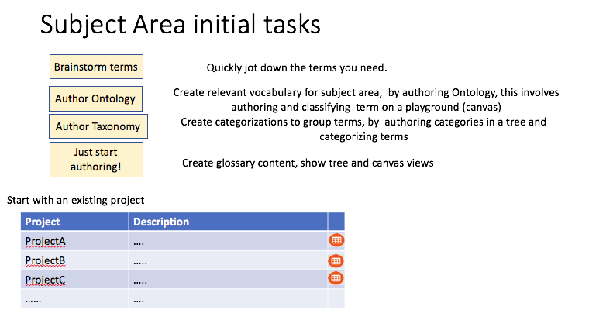

Figure 3 Subject Area Home screen

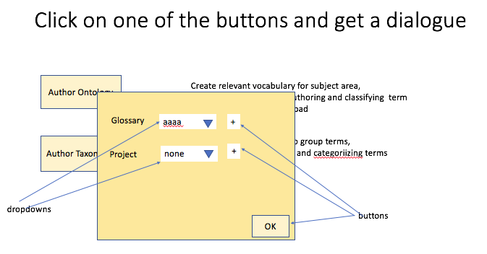

Rest calls

* Create project
* Create glossary

Figure 4 specify Glossary and optional project

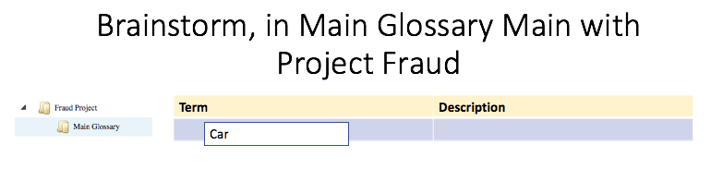

Rest calls

* Create term

Figure 5 Brain storm - jot down new term name

For a brain storm we are looking to get down a list of terms names quickly in the list and maybe put in some description content as well. As the row is left the Term is created

The request to create the term indicates that it has ‘proposed’ status. The OMRS implementation will either return:

* a term with status ‘draft’ if the OMRS support draft status (for example IGC).

or

* a term with status ‘active’ if the OMRS does not support draft status (for example Atlas October 2017).

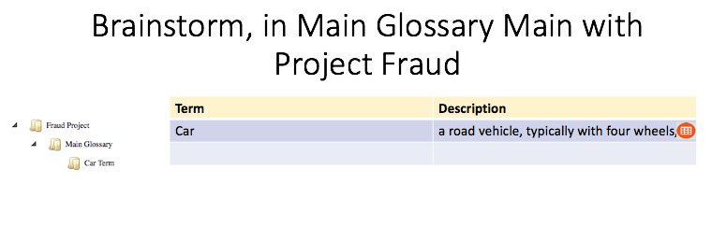

Figure 6 Brain storming - one term created

Figure 6 shows a term has been created – a new row is displayed to be able to easily add the next term. The new term is shown under the project’s glossary. The term can be deleted using the delete icon.

Note that the Car will be decorated with the Term icon be default.

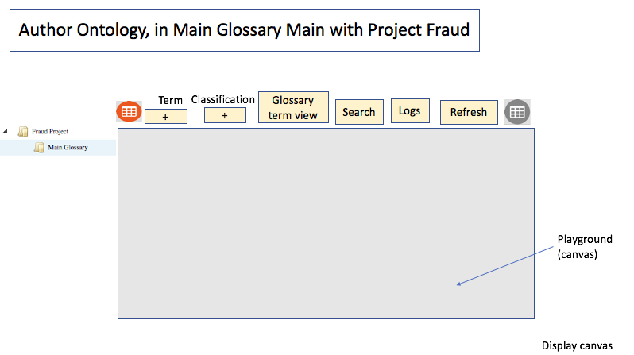

Rest calls

* Get any existing project content.

Figure 7 Ontology: working with a playground

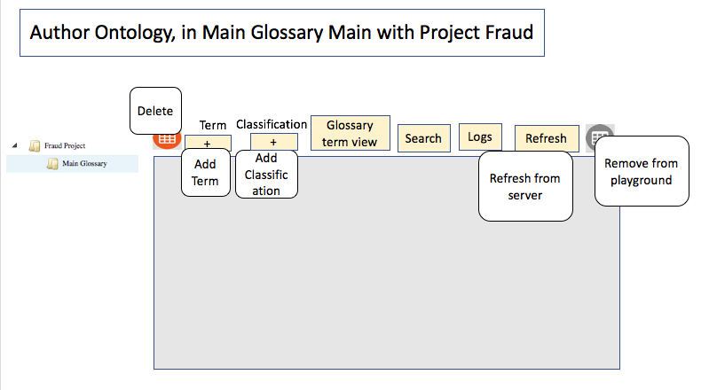

Figure 8 tool tips

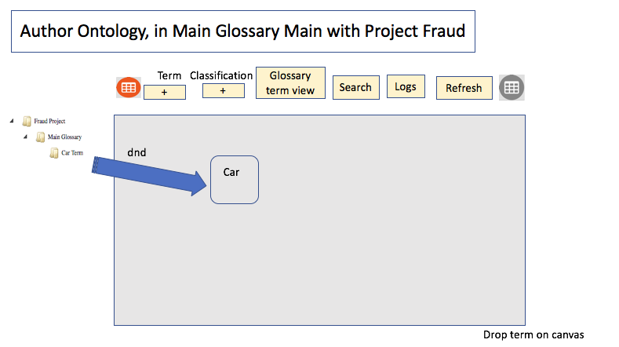

Figure 9 Ontology add a term by dropping on the canvas from project

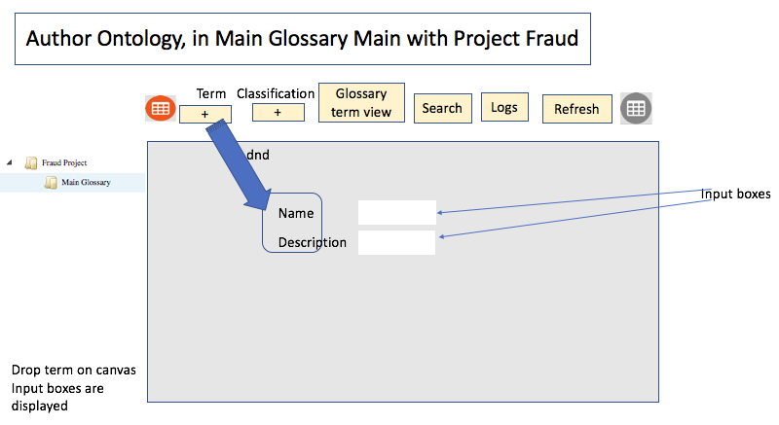

Figure 10 Create term

Figure 10 shows a new term being dropped on the canvas- and the user being prompted for basic input; name and optionally a description. Note that as dialogues are not so in fashion – it might be better to consider sliding out a new area to the right of the canvas for this .

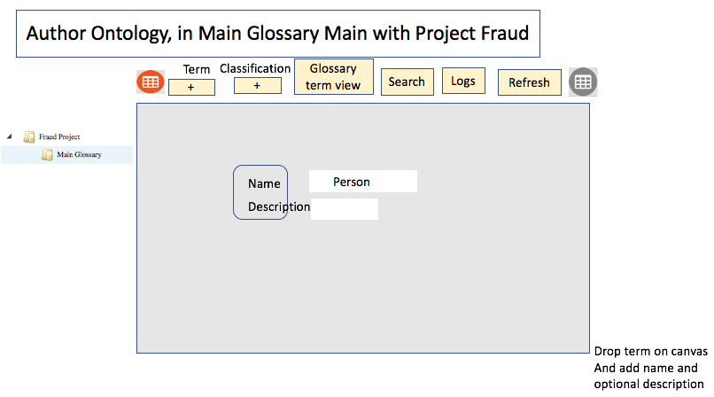

Figure 11 input new term name

As the dialogue closes then we issue the Rest call.

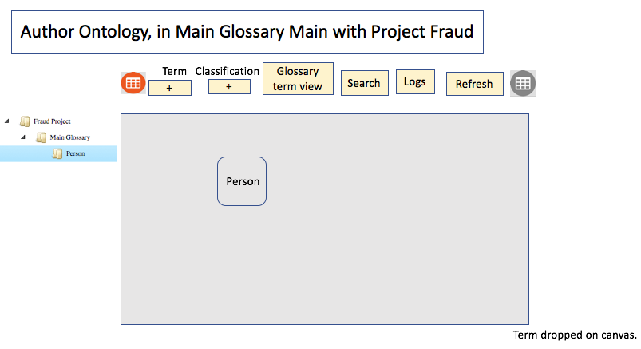

Rest calls

* Add term

Figure 12 a term is now on the play area (the canvas).

Missing some screens here is a second term added

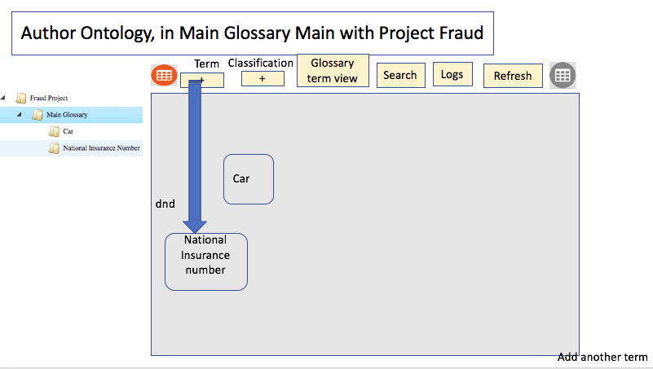

Rest calls

* Add term

Figure 13 Add another term

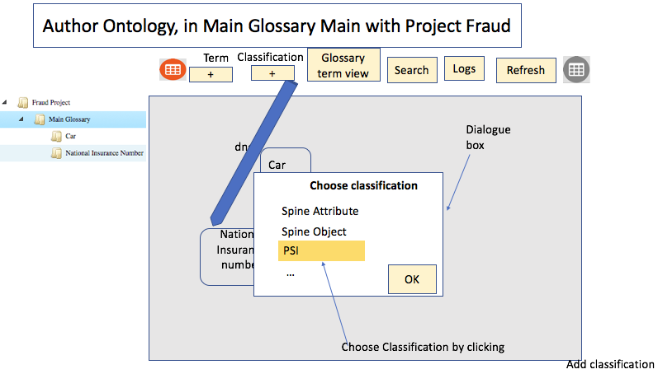

Rest calls

* Get classifications

for term type

Figure 14 Add a classification

Figure 14 shows a list of appropriate classifications from the server that can be applied to a term.

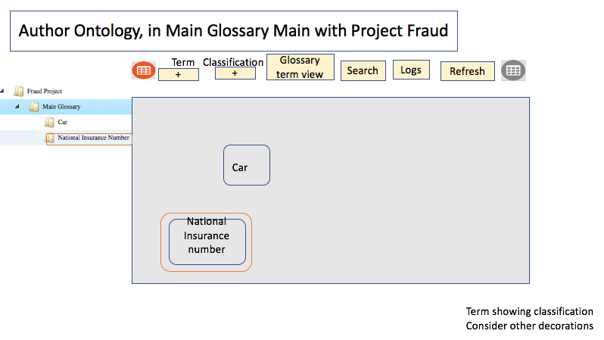

Rest calls

* Add classification

To term

Figure 15 Term decorated to show it has a classification

Decorations of classifications are more likely to be icons and we would only show a maximum of say 5. In time, the UI could become more sophisticated with user settings.

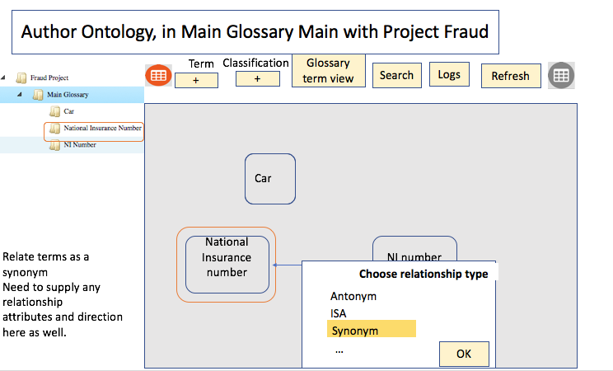

Rest calls

* Get term to term relationships types

Figure 16 choose relationship type

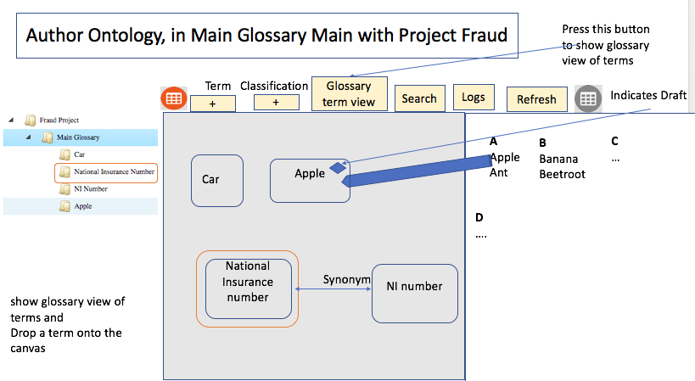

Rest calls

* Get term names in Glossary (and outside?)

Figure 17 Glossary of terms

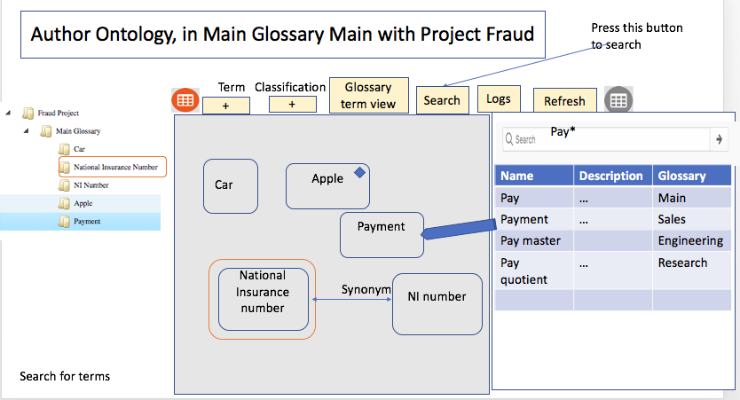

Rest calls

* Issue search

Figure 18 Search for existing terms to work with

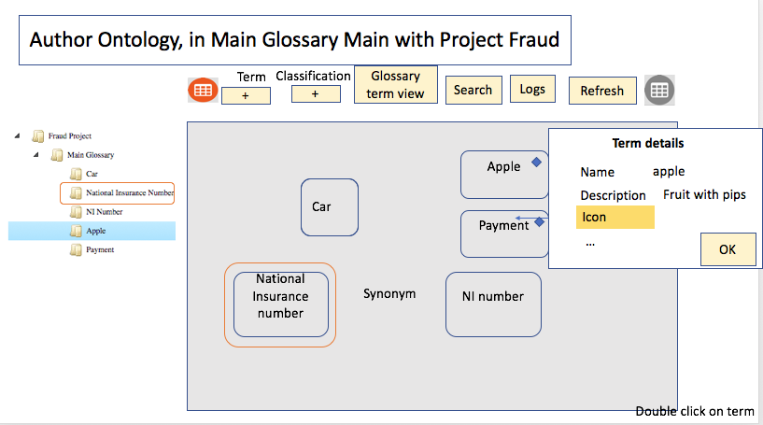

Rest calls

* Get term details from the server

Figure 19 Update Term details

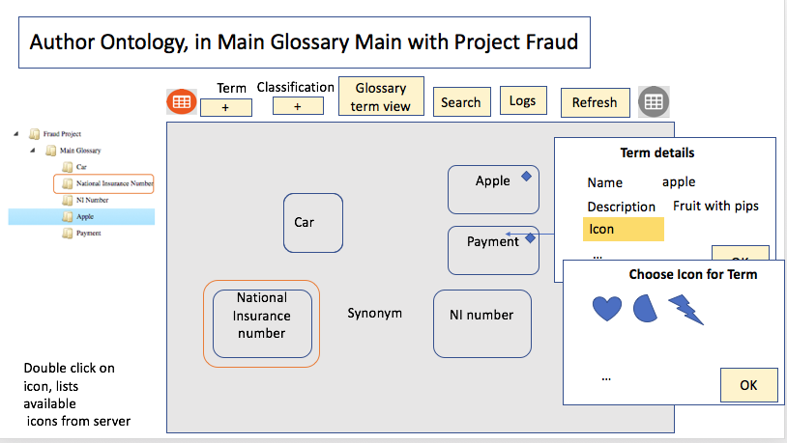

Rest calls

* Get icons from server. Should be pageable and searchable.

Figure 20 Pick an icon from the server

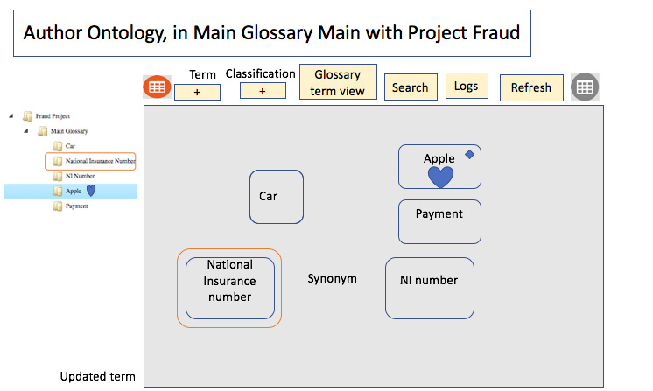

Rest calls

* Update term

Figure 21 Update a term to give it an icon

It might be that we want to allow this user to add icons they would like to associate with a term.

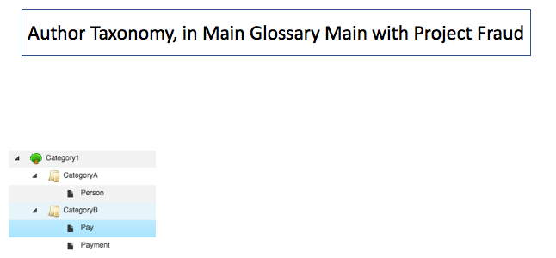

Rest calls

* Get existing project content.

Figure 22 Taxonomy

Figure 22 Taxonomy shows a category tree. A project can contain category tree, containing categories, the categories can contain terms.

It is possible to copy and paste terms under categories.

It is possible to drag and drop (cut and paste) terms under categories.

It is possible to drag and drop (cut and paste) categories under categories.

Note that logic will need to ensure that dragging any category into the tree brings in its children.

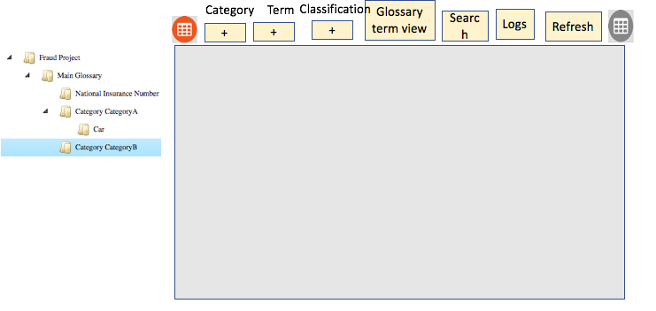

Figure 23 Tree and canvas

Figure 23 Tree and canvas shows a tree and a canvas. It is possible to drop terms onto the canvas to be linked together.

## UI considerations

It might be that if the canvas and the tree are each separate web components, then we could start multiple of these components in different contexts that we could drag and drop content between. In this case the buttons would likely live inside the component.

TODO I am not sure whether / how Polymer supports drag and drop between web components.

Dragging an object onto the – (delete) button over an object deletes it from the server if it exists there or just moves the object to trash

Dragging an object into the trash button means we remove it from our canvas.

Refresh takes the guids that are on the canvas and checks whether they have changes or not with the server using the last update date check. If they have changed then the canvas is updated with the server versions – a warning will be issued if we see a deletion.

The tree needs to show terms and categories under a glossary, so it is possible to

* Copy and drop from the Terms into the category tree
* Cut and drop a term or category around the category tree.

## Models

There are open metadata resource models, that will result in new types. The OMAS will need to map to these types. There will be an OMRS layer that the OMAS uses to access these types.

### Glossary Models

https://cwiki.apache.org/confluence/display/ATLAS/Area+3+-+Glossary

|  |  |
| --- | --- |
| * 0310: Top-level Glossary object definition. * 0320: Glossary Categories and their relationships. * 0330: Glossary Terms and their relationships to Glossary and Category. * 0340: Semantic classifications for glossary terms | * 0350: Semantic relationships between Glossary Terms * 0360: Defining contexts in the glossary * ~~0370: Semantic assignments for metadata entities~~ * 0380: Structuring relationships between Glossary Terms |

<https://cwiki.apache.org/confluence/display/ATLAS/Area+5+-+Standards>

The reference management model content has not been created yet.

## IGC and Atlas OMRS considerations for the Subject Area OMAS API

The OMAS issues calls that get different styles of responses because the OMRS layers support different capabilities. The 2 OMRS repositories that we are looking at initially are IGC and Atlas. The OMAS code needs to be flexible enough to be able to handle OMRS responses from different capabilities.

|  |  |  |
| --- | --- | --- |
| Capability | IGC | ATLAS |
| Workflow | Supports draft state | No support for draft state |
| Relationships | Does not have the concept of a top level relationship | Supports top level relationship concept in a Relationship API and also in the entity API. I assume that the OGC connector does not need to supply a relationship guid |
| Glossary | IGC does not have a top-level concept of a Glossary. | Atlas has a top-level concept of a Glossary. |
| Project | IGC does not expose the concept of a project | Atlas has a project. |
| Term Category parent | A Term can only live in one category, can have secondary categories. | A term can live in many categories. |

### Workflow

OMAS expects creation of new terms and categories and glossaries to be done passing the status PROPOSED. IGC will return a DRAFT status and Atlas will return an ACTIVE status.

### Relationships

Atlas supports CRUD operations on a top level concept of a relationship. The Atlas entity API also supports RelationshipAttributes, these are attributes with non-local types – these relationships can be 1 to 1 or 1 to many and can also indicate containment. Atlas also supports attributes on the relationship itself.

IGC does not support top level relationship APIs, so OMAS calls that require this concept will fail.

IGC exposes attributes in top level concepts that are references – primary keys. This means that some of the content that would come from the Atlas AtlasRelatedObjectId will not be present for IGC – for example relationship guid and attributes of the relationship.

### Glossary

IGC OMRS needs to be able to work with Glossary object – otherwise the API will not work.

### Project

IGC does not have a top level project.

### Term Category Parent

Mapper needs to cope with this.

## Subject Area OMAS API

To enable the OMAS UI prototype we need to be able to

* + get glossaries
  + get projects
  + add glossary
  + add project
  + Update glossary (not in current UI)
  + Update project (not in current UI)
  + Delete glossary (not in current UI)
  + Delete project
  + get existing project content
  + get classifications for term
  + get icons from the server
  + search for terms with a wild card across multiple glossaries
  + get details of entities given a list of guids (this is the refresh case – maybe we send up the last update dates and the guids and only return entities with newer dates)
  + Add term
  + Delete term
  + Update term
  + Add category
  + Update category content
  + Move category in tree
  + Delete category
  + Map term to category
  + Unmap term to category.
  + Add, update, delete classifications from term, category or glossary.

|  |  |  |  |  |  |  |  |
| --- | --- | --- | --- | --- | --- | --- | --- |
|  | Term | Category | Glossary | Project | Classification | List of guids | Icons |
| C | Y | Y | Y | Y | Y |  |  |
| R | Y | Y | Y | Y | Y | Y | Y |
| U | Y | Y | !UI | !UI | Y |  |  |
| D | Y | Y | !UI | Y | Y |  |  |
| Search | Y |  |  |  |  |  |  |

!UI = not yet in the story board UI

Y = rest call required

### Names and identity

Elements exposed by the Subject Area OMAS objects need to map to the OMRS entities. Some are identified by guid (like entities) and some are identified by name like classifications.

The fully qualified names for glossaries, terms and categories need to be unique; as they map to the fqname in Referenceable.

Glossary fqname – is the name of the Glossary for example CustomerTaxonomy

Term fqname – is the name of the Glossary dot name of the term. For example MainCanonicalGlossary.Address

Category fqname – is the name of the Glossary dot name of the category. For example CustomerTaxonomy.GoldCustomers.

Category children should be uniquely named (category children may live in other glossaries).

Note that the OMAS element Term maps to Atlas GlossaryTerm. The subject matter expert is working with glossary so does not need the Glossary prefix on the name of terms. The same for Category.

## Appendix

Some thoughts that may not be in line with the latest thinking. I am questioning whether this omas needs to expose a tree or graph API – as we are unlikely to be doing a page level submit. So much of the below thinking may now not be relevant.

### Exposing Terms with different amounts of information

Assets are exposed in summary, detail and unverse levels- each level exposing more information about and around the asset.

Instead of this approach, I suggest we use Term (which has all the associated information – similar to universe asset). The main use case for this API is to be able to show terms in grids, graphs and trees. I therefore propose that we use graph and tree APIs to expose the displayable parts of terms, categories and glossaries. In this way, appropriate subsets of term (categories, glossary, assets, classifications) can be displayed. Grids will use the term as a row.

We would like to get terms alphabetically – so we need a template A* , B* etc.

Tree or graph node – information required to draw a term (name, icon, description (for hover text), visualizable classifications (without the attributes), visualization parts of relationships (without the attributes).

TreeNodes also need to have a hasChildren.

GraphNodes: the exact format will depend on the graph being used (e.g. jquery style)

Term (full information)– this is all of the information associated with the term, full details of classifications and relationships including their attributes.

The candidate term use case could use a graph or tree to create terms in a glossary with just a name. Optionally a description and project could also be used. At these candidate terms are later wired up the same graph / tree node structures can be used to represent the term as a node.



Figure 24 Term

Assets are only shown with enough detail to draw it (similar to the Glossary detail); there is no ability to perform CUD operations on them or mappings to terms.

Terms, categories and glossary have the Atlas system attrs – I have but this in entity in the omas project. Similar for classification. I do not think that different OMASes should be allowed to rename the Atlas system properties.

Discussion points

* + I propose for glossary we have term which is everything, graph and tree elements (which are visualizable and would be used for candidate terms). Proposing not having details or summary for term.
  + Perf logging option is required
  + Common omas structures allowed ? I suggest system attributes, some enums like Active & Delete – do we want draft or keep work flow state separate? Paging mechanisms.
  + Exposed Search API, basic allows types, attributes, classification; this is not enough. I suggest we allow this style of API with patterns (we need to be able to grab A* terms for a glossary to be able to show an alphebatized glossary view – so probably need to implement using DSL). Atlas has a full text search – do we want to expose this style of API – it would be useful for google for data.

## UI Visualization styles

The user wants to work in a UI with one of these 4 visualization styles. The Subject Area OMAS API needs to work naturally with these visualization styles.

### 1) Tree

- the top node is a Glossary Category or Term

  - the elements in the tree need to be visualizable; for terms glossaries and categories this is the detail level. The OMAS therefore needs

- visualizable Term

* short - enough to paint it on the screen - label, hover text, icon, id and hasChildren flag.
* long form. This will be the same as glossary term except
  + links to terms, classifications, assets are all in the children attribute with a type (CLASSIFICATION, TERM,ASSET[1]).
  + There needs to be indications to say whether an element to be displayed is editable – so the UI can grey it out.

-visualizable category in short and long (same as term).

- visualizable asset.

- visualization classification.

- when we get an element’s children the result needs to be pageable.

- A nice to have would be an API that would allow the actual shape jQuery requires to be defined. I am thinking of an API that would have key/ value pairs that map to the visualizable term elements. The Key would be the name we want and the value would be the standard field name in the visualizable term. In this way, we could do one to one mapping and create the expected structures for a framework like jQuery.

e.g. jQuery jstree (<https://www.jstree.com/docs/json/)> can take:

{  
  id          : "string" // will be autogenerated if omitted  
  text        : "string" // node text  
  icon        : "string" // string for custom  
  state       : {  
    opened    : boolean  // is the node open  
    disabled  : boolean  // is the node disabled  
    selected  : boolean  // is the node selected  
  },  
  children    : []  // array of strings or objects  
  li_attr     : {}  // attributes for the generated LI node  
  a_attr      : {}  // attributes for the generated A node  
}

Web components seem similar but have actions as well. I propose actions are not stored in Atlas. In time, we may want to save the UI actions and icons etc as metadata.

In this view - it should be easy to add, rename, update a term or category in context.

I suggest this view cannot update classifications - but does show them as children

### 2) Graph

-allow easy visualization of graphs in D3. Maybe expose the jsongraph format. Ideally allow creation of new terms as vertices that can be wired together

* + We need to ensure we have a way to scope what is displayed. Maybe 3 hops out from a starting point.

### 3) Grid

    This would be most useful to display a particular element type for example a glossary term or category.

* + similar to the tree we expose the detail term and a mapping so the format can be customized in the API

    - this view would make it easy to update entry content

* + in this view, it would be possible
    - to see and update the relationship attributes.
    - Create and delete entries of a type.

### 4) Alphabetised

Glossaries are often displayed as an alphabet – such that the content for letter A is accessed by pressing that letter.

## How a User Interface using the Subject Area OMAS might be organised

From an empty system, there some ways to populate the metadata:

* Starting from and empty system Glossary content can be manually authoring terms and categories. This could be done programmatically in some sort of ETL or ELT process.
* Glossary content could imported
* A working group could author a glossary from scratch.

The User Interface is likely going to oriented around tasks or starting points that allow tasks to be performed in context. Getting the context to be able to create a new term or map an asset to a term is likely going to involve:

1. It might be that we want to navigate down from the top of a glossary to find a part of the hierarchy we are interested in. But more likely we will search.
2. A search specifying a query predicate. The search might need to return items of a certain type – for example find me term names that include the word ‘customer’. I can see a place for all the low level Atlas search paradigms here (Basic, full text, DSL). I suspect we are looking for assets , terms, categories and glossaries.
3. Typically, a search will return a grid of results.
4. The grid might be a useful display of artifacts that the user wants to work with as is. It should also be possible to choose an element in the grid and use this to visualise a tree or a graph based around that element.

Once we have found the context we are interested in, we then should be able to:

* Navigate further from what we have found
* Issue CRUD for terms and categories.
  + Update includes rename and moving categories around.
  + Create include creating relationships to classify terms, relate terms.
* Classify glossary elements.
* Explore associated lineage

## Swagger

I have put together some code to generate some Swagger for review <https://reviews.apache.org/r/60681/> and Jira 1698. I suggest feedback around the API details is done in the review board tool or on the Jira.

Some assumptions about the OMAS API (some of them inspired by Graham Wallis’s review)

* We expose the search API (basic filtering and DSL) in the OMAS. I think that the OMAS needs to return a List of Referenceables in the Search response. I think we do not need to return the EntityHeaders for the OMAS as we always want to populate complete screens with all the attributes (unless there comes a time where the user can request a subset of columns to display)
* All rest url segments are singular even when many entities are returned.
* The glossary, term and category guids are assumed to be unique in the Atlas system. We do not need to have Rest calls that have glossary/{glossaryguid}/term/{termguid} just /term/{termguid} is required.
* No Atlas objects are exposed. Atlas only appears in the package name

Here is a screenshot of the Swagger methods



Here is the Term structure

| Properties | | |
| --- | --- | --- |
| **name** | **data type** | **description** |
| displayName | string | Display name - text meaningful to the user. |
| shortDescription | string | Short description of the term. This could be used as hover text by a user interface. |
| projects | array of string | The names of the projects associated with this term. |
| examples | string | Text showing examples of this glossary term |
| abbreviation | string | Abbreviation of this term name. |
| usage | string | Usage description |
| media | array of EmbeddedMedia | Media associated with this term. This could contain an icon for the term that the user interface could use to represent the term visually on a canvas or in a widget. |
| relatedTerms | RelatedTerms | Related Terms contains relationships used to show how the meanings of different terms are related to one another. |
| contextRelevantTerm | array of Context | ContextDefinition classification indicates that the term describes a context. Context definitions is linked to the relevant term using |
| usedInContext | array of Context | ContextDefinition classification indicates that the term describes a context. Glossary Terms that are relevant in that context are linked to the context definition term using the UsedInContext relationship. |
| semanticAssignment | array of SemanticAssignment | Semantic assignment is the association of a term with an asset. The asset meaning of the asset is enriched by the association of relevant terms |
| spineObjects | SpineObjects | Glossary terms can used as spine objects, spine attributes or spine identifers; this is enabled by applying the appropriate classification (e.g. the TermHASARelationship classification). These TermHASARelationship relationships relate the terms via inheritance or as objects and attributes. |
| anchor | Anchor | The term anchor links each term to exactly one Glossary object. This means that this is its home glossary. If the Glossary object is deleted then so are all of the terms linked to it. |
| assignedEntities | array of SemanticAssignment | Entities that this term is associated with. |
| termCategorizations | array of TermCategorization | Categorizations associated with this term |
| externalGlossaryLink | array of ExternalGlossaryLink | External glossary links |
| **Properties inherited from****Entity** | | |
| serialVersionUID | number |  |
| guid | string | Unique identifier for this object. It is generated at create time and is used to identify the object for gets, updates, deletes and when creating relationships. |
| status | Status | Status indicates the state of the object - the values are specified in the Status enumeration |
| createdBy | string | User who created this object |
| updatedBy | string | Use you update this object |
| createTime | number | time at which this object was created. |
| updateTime | number | time at which this object was updated. |
| version | number | version of the object. |
| qualifiedName | string | Allows this object to be referenced by qualified name. |
| owner | string | Owner of the term. |

## Mapping from Subject Area OMAS Glossary types to Atlas types

The Subject Area Glossary types and attributes are the same as the Atlas Area 3 types and attributes for:

* All classifications and their attributes
* Subject Area Glossary and its attributes and relationships

Subject Area Term maps to Atlas GlossaryTerm – it is expected to be used in a project.

Subject Area tree and graph elements can map to relationships and a displayable subset of attributes for the following Atlas types:

* Glossary
* GlossaryTerm
* GlossaryCategory
* AtlasClassification
* Asset

The graph and tree elements can be greyed out if readonly.

Atlas GlossaryTerm does not support workflow states. The Subject Area OMAS supports a draft OMAS state. I suspect we want to keep workflow states like ‘pending review’ and ‘approval’ separate from status.

There are Subject Area search operations that are scoped by glossary – as this will be used a lot. The search allows a filter (regex expression) to allow alphabetical glossaries to be created (grab all the terms beginning with A then B etc.

## Discussion points

Some of the above ways of thinking about the OMAS API as likely to be useful for the other OMAS’s.

Does the API need to do anything to enable accessibility?

Does the API want to do anything specific around globalization?

1. Or the ASSET type.